Ivan  Copeland | 24 De Stadler Ave  Capri  M 0799229061  ivan.copeland2018@gmail.com  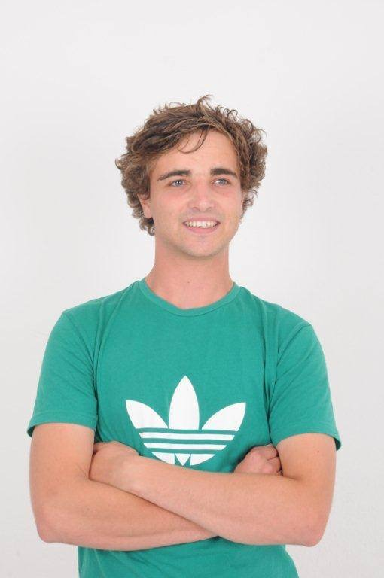

Summary My name is Ivan Copeland. I am very interested in building my experience in the working world. I am friendly and disciplined. I am skilled in customer service. My experience includes working at as a barista and doing food delivery.

Experience Modelling Work
Model work for commercials and photo shoots.
April 2010 - August 2012

T-shirt Business
Created and sold original design T-shirts both personally and stocked in store.
2011

Organic Market
Grew and sold organic vegetables locally.
2013

Freelance Work
Created animated videos for Eco Safety (Health & Safety Business) for a 3 month period.
2013

Delivery Extreme
Food delivery.
November 2013 - March 2014

Espresson.Kom
Barista for local coffee shop in Kommetjie.
January 2015 - April 2015.

Education Primary School Education:
Mc Gregor Waldorf (2002 - 2005)
Imhoff Waldorf (2005 - 2007)
Secondary School Education:
Constantia Waldorf (2007 - 2009)
Valley Tutor Centre (2010 - 2013)

Highest grade passed: IGCSE as well as some AS Levels.
Subjects passed:

English (IGCSE & AS Level)
Physics (IGCSE & AS Level)
Mathematics (IGCSE)
Business Studies (IGCSE)
Information & Communication Technology (IGCSE)
Biology (IGCSE)
Physics (IGCSE)

___________________________________________________________________________
Skills I like working with people, I am excellent at Maths and good with children as I have many younger siblings. I believe I am reliable, diligent and can show initiative in a working environment.
My interests are gardening, being creative and spoken word.

References Delivery Extreme:

Ryan Emerood / Tamara, Manager (Tel no: 021 - 671 1144)

Espresson.Kom:

Carol, Owner (Tel no: 021 – 783 0342)

